Judge a book

In this project, you will investigate whether it’s really possible to judge a book by its cover.

You will make a game in Scratch for a friend to compete against your computer to see who is better at guessing the genre of a book based only on its cover.

To do this, you’ll first need to train your computer to recognise book covers.



This project worksheet is licensed under a Creative Commons Attribution Non-Commercial Share-Alike License

http://creativecommons.org/licenses/by-nc-sa/4.0/

1. Go to <https://machinelearningforkids.co.uk/> in a web browser
2. Click on “**Get started**”
3. Click on “**Log In**” and type in your username and password  
   *If you don’t have a username, ask your teacher or group leader.*
4. Click on “**Projects**” on the top menu bar
5. Click the **“+ Add a new project**” button.
6. Name your project “judge a book” and set it to learn how to recognise “**images**”. Click “**Create**”  
   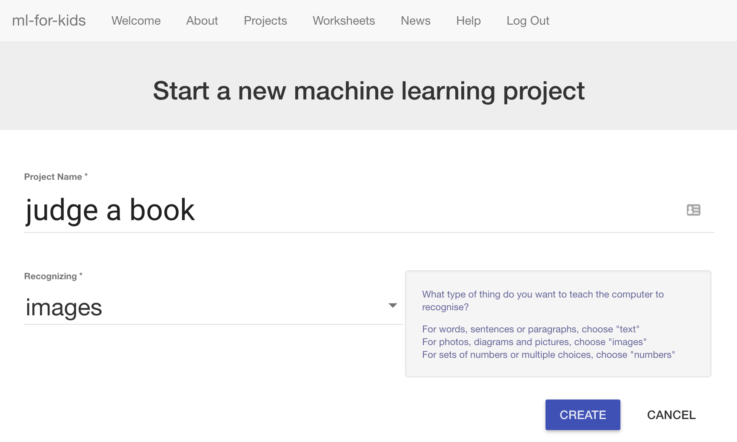
7. You should now see “judge a book” in your projects list. Click on it.  
   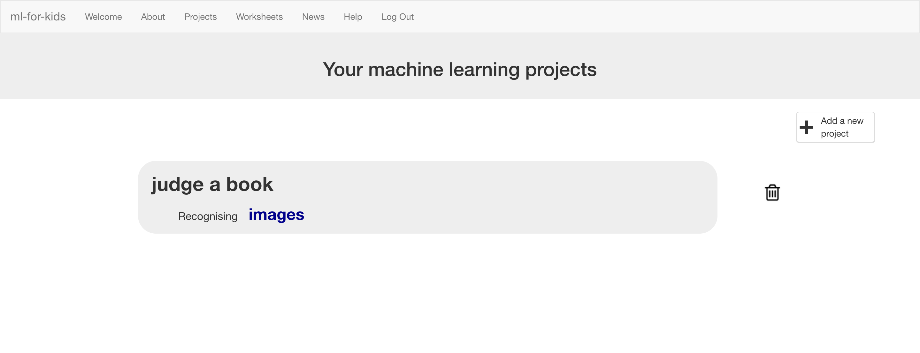
8. Click the “**Train**” button  
   
9. Choose a few genres of books.   
   *“Genre” means the type of story*.   
   *For the rest of this worksheet, I’ll be using:   
    “children’s”, “sci fi”, “romance” and “thriller”.   
   The project will be easier if you use these as well. But if you’re feeling adventurous, try choosing between 3 and 5 of your own instead!*
10. Use the “**+ Add new label**” button to create a bucket for each genre of book you’re using.  
    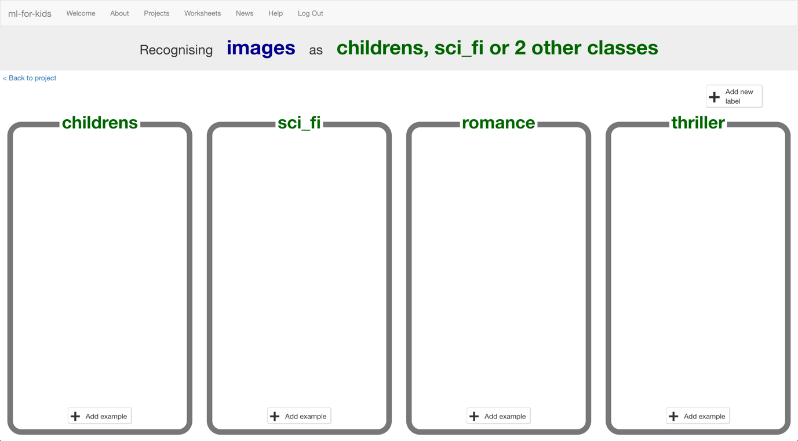
11. In another web browser window, find pictures of book covers.  
    *You need to find a website of pictures of book covers. This could be a library website, or a site that sells books like Amazon. Find a site that groups books by genre already to make it easier for you.*  
    *Arrange the windows so your training buckets are next to the book site.*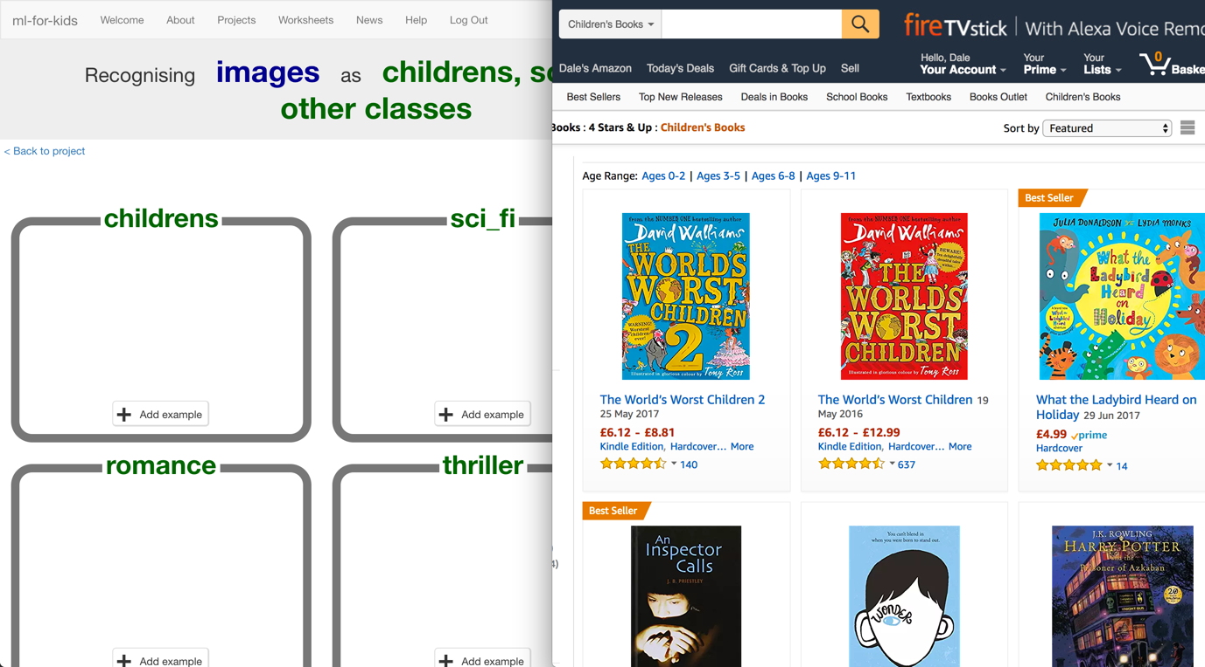
12. Find pictures of book covers in each genre you’ve chosen. Drag the best examples into the buckets in your training page.   
    *Try and find about 20 examples of each genre.*   
    
13. Save some different pictures of book covers to a folder.   
    *Ask your teacher or group leader if you’re not sure how to save a picture from a website.*   
    *These are the pictures that you’ll use to test the computer with. It’s important that none of these are the same as the covers you gave to the computer in step 12.*    
    
14. Click the “**< Back to project**” link. Then click “**Learn & Test**”.
15. Click “**Train new machine learning model**”.  
    *As long as you’ve collected enough examples, the computer should start to learn how to recognise covers from the examples you’ve given to it.*  
    
16. Wait for the training to complete. This might take a few minutes.  
    
17. Click the “**< Back to project link**”. Then click “**Scratch**”.  
    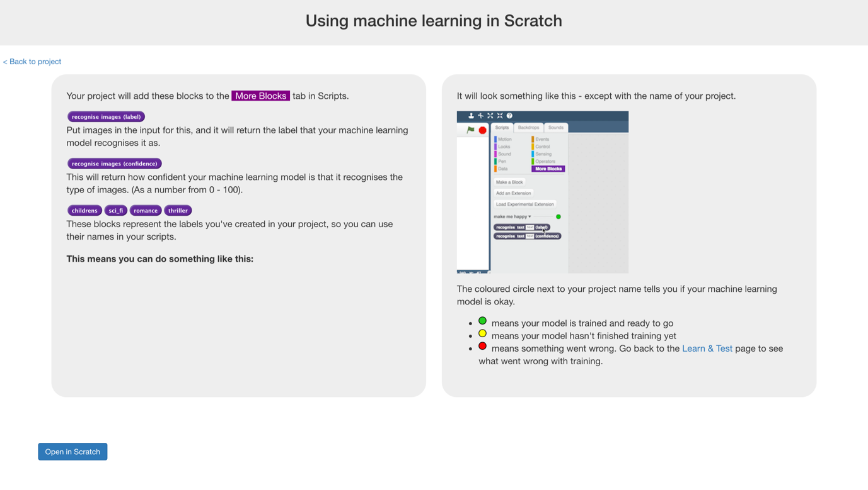
18. Click the “**Open in Scratch**” button to start making the game.  
    *You should see new blocks in the “More blocks” section from your project.*  
    
19. Open the Judge a Book project template.   
    *Use* ***Project templates*** *->* ***Judge a book***

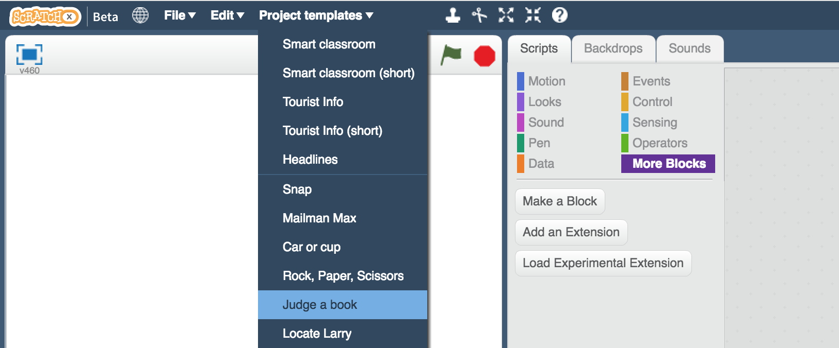

1. If you used different book genres to me, update the “Human says” buttons. Use the costume editor to update them so the labels match.   
   *There are a few scripts in these buttons that make them look different when they are clicked. You don’t need to update the scripts.*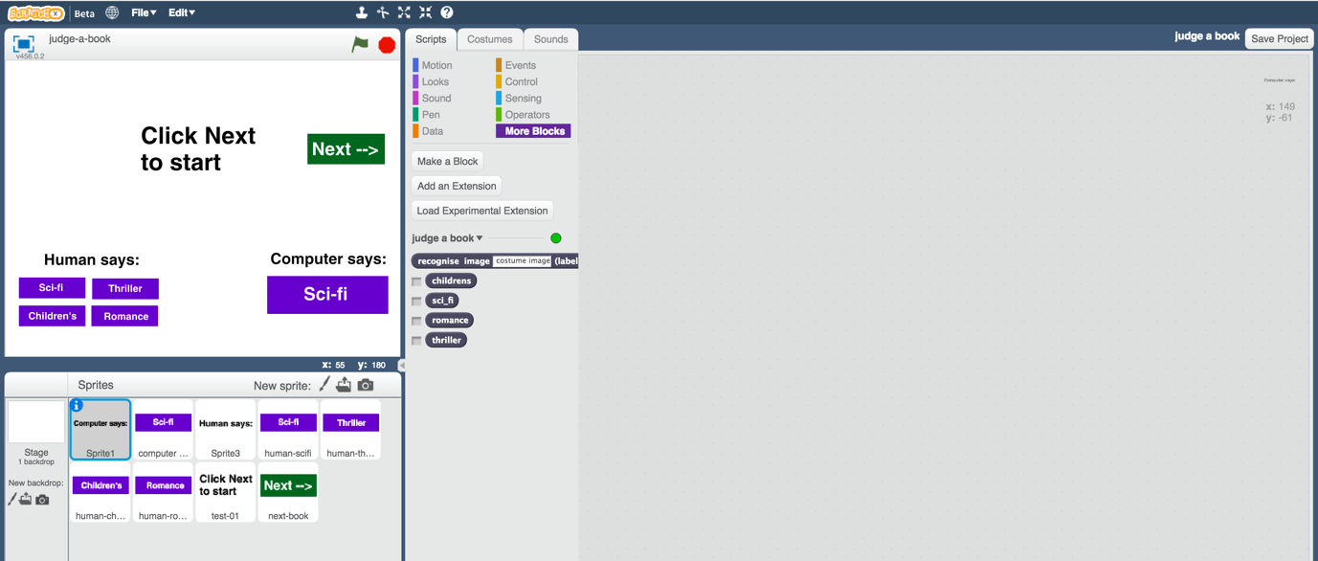
2. Click on the “**test**” sprite   
   *It’s the one that has the “Click Next to start” message.*
3. Enter the following script blocks for the “**test**” sprite  
   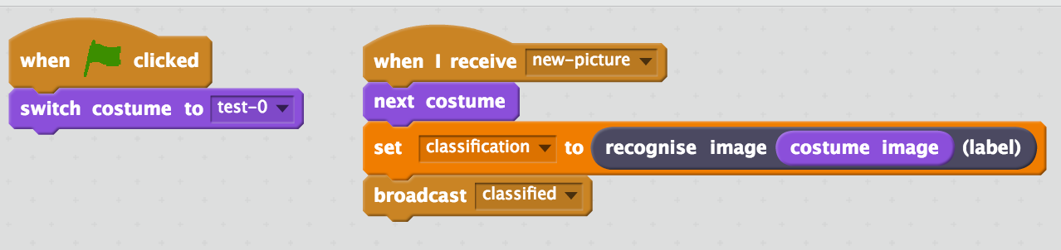
4. Click the “**Costumes**” tab.   
   Click the “**Upload costume from file**” button with the folder icon.  
   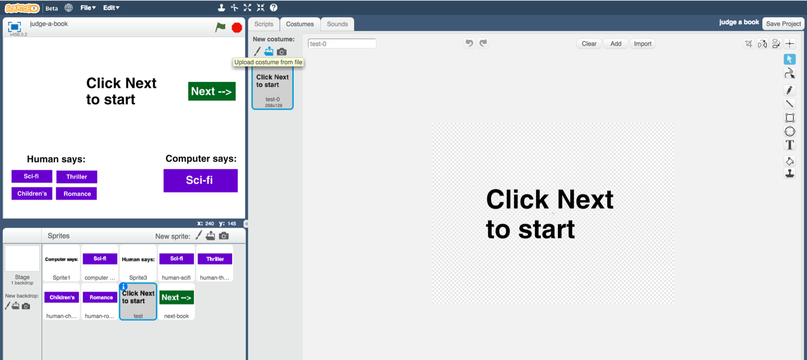
5. Upload all of your test images from step 13.  
   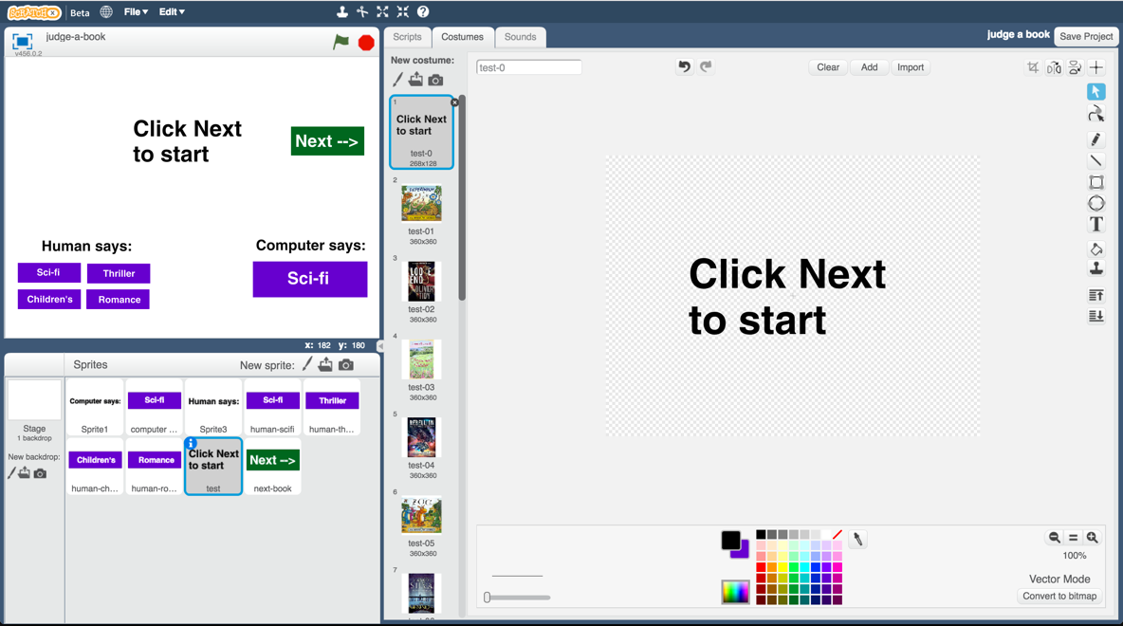
6. Click on the “**computer guess**” sprite  
   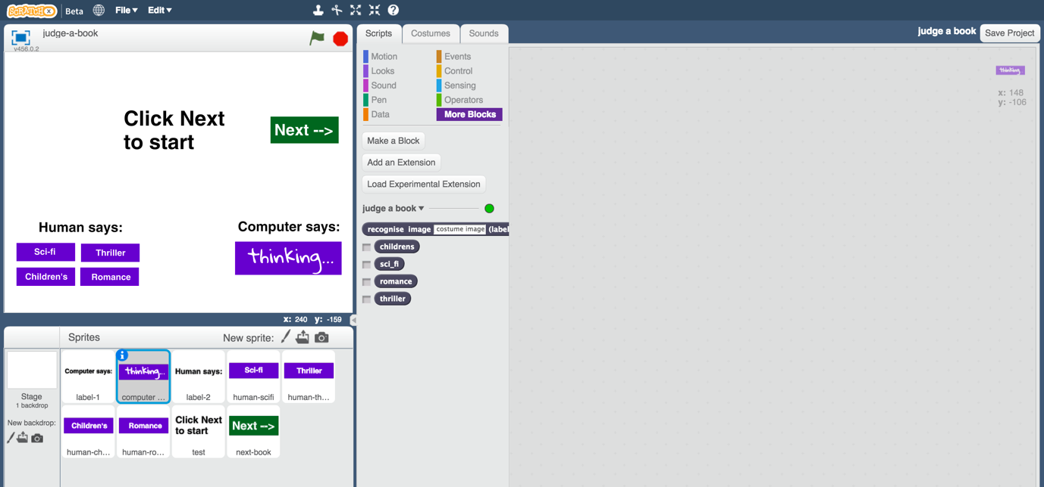
7. Enter the following script blocks for the “**computer guess**” sprite  
   *This is how the computer will display its guess for each book cover you will test it with. If you’re using different book genres, update it to match.*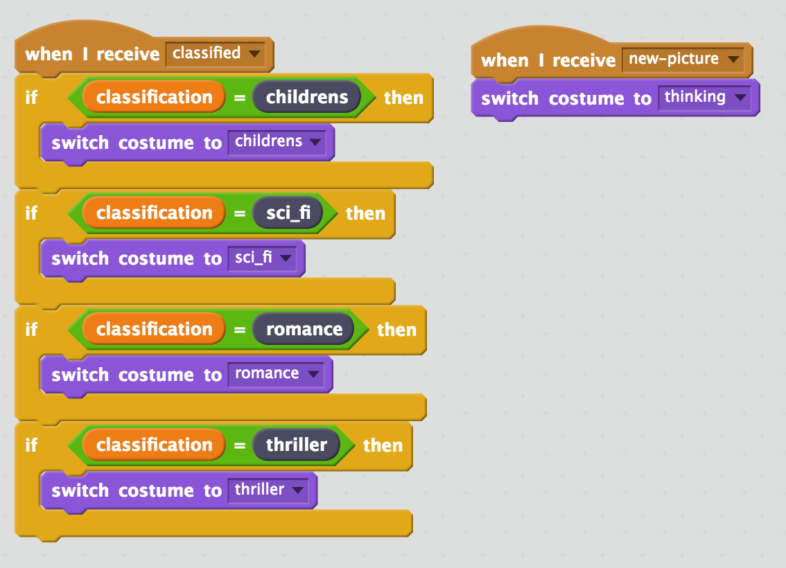
8. It’s time to test!  
   To make this fair, you haven’t shown the test images to the machine learning computer.  
   To be equal, find a friend to test this that hasn’t seen your test images.   
   *Click the fullscreen icon, and then click green flag.  
     
   They should click the “Next” button and they’ll see a book cover.   
     
   Ask them to guess what genre book it is from the cover, and click one of the “Human says” buttons on the left to confirm their choice. (It doesn’t do anything other than look different).   
     
   The computer will try and decide what genre it looks like, and display its answer under “Computer says” on the right.   
     
   If they click “Next” they will move to the next book – ask them to keep going through all your test images.   
     
      
     
    *

**What have you done?**

You’ve created a game that tests whether people and computers can judge a book by its cover.

Specifically, you’ve trained a machine learning model to classify pictures. The computer learned from patterns in the colours and shapes from each of the images you’ve given it. These were used to recognise new photos.

You’ve also learned about a key way that we measure how good a machine learning system is: by comparing its performance against a person. This is a common approach for tasks where the right answer isn’t already known.

A good example is the task of recognising the words someone is saying : “speech recognition”. Humans miss one to two words out of every 20 we hear. So computer systems trained to recognise speech are compared against this.

**Ideas and Extensions**

Now that you’ve finished, why not give one of these ideas a try?

Or come up with one of your own?

**Keeping score**

Can you update the Scratch game so that it keeps score?   
  
Is the computer as good at recognising book genres as the people that you can get to test it?